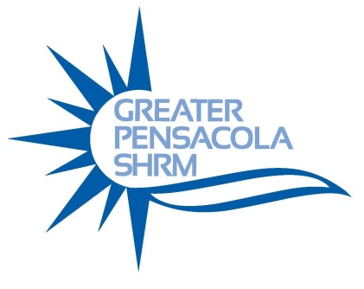
Justin Libak
Recruitment Branding & Strategy Executive
Local IQ Recruitment

Justin Libak is a leading Account Executive for The USA TODAY NETWORK. Over the past Six years, Justin has worked with companies ranging from 10 workers to Fortune 50 organizations with thousands of employees, helping those businesses attract qualified and skilled job candidates. With over eleven years’ experience in sales consulting, Justin serves his clients as an expert recruitment adviser and provides them use the latest digital tools and strategies to connect with top talent. In addition his professional experience, Justin holds a bachelor’s degree and an MBA from the University of Indianapolis.

